# Setting Up the HTML Webpage

Connect your PLC and create a new Project in TIA Portal to begin

Click on the PLC and select Properties > PROFINET interface > Enable Web server using this interface

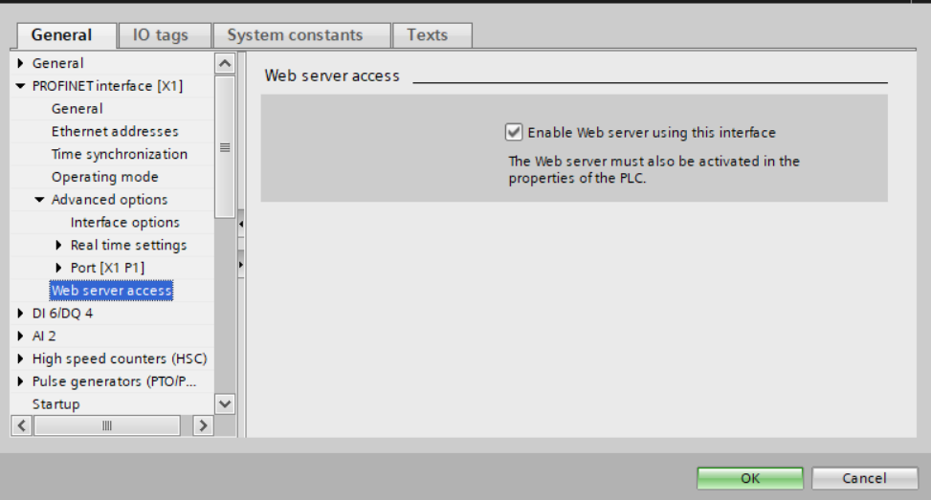

Scroll down to Web server > General > Activate Web server on all modules of this device

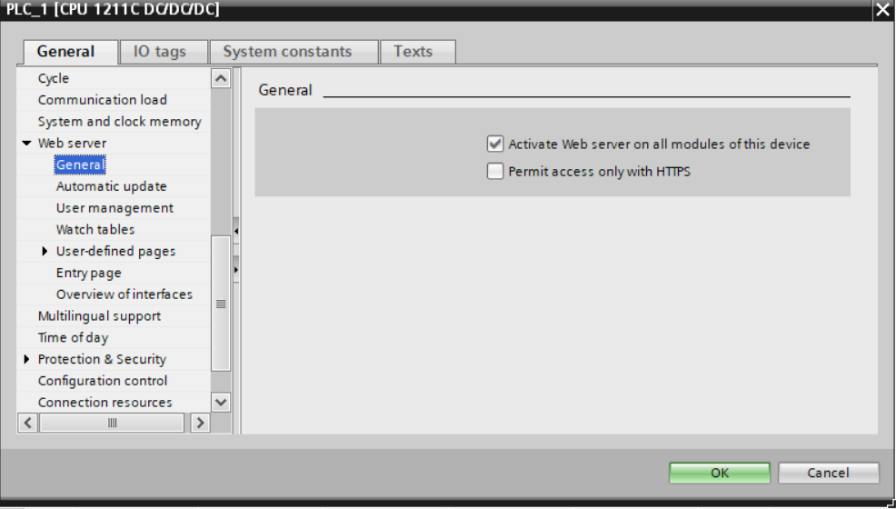Note: If Permit access only with HTTPS is enabled, the server may kick it off if it is not “safe” by Balluff’s standards. If creating this project simply for testing reasons, do not select this button.

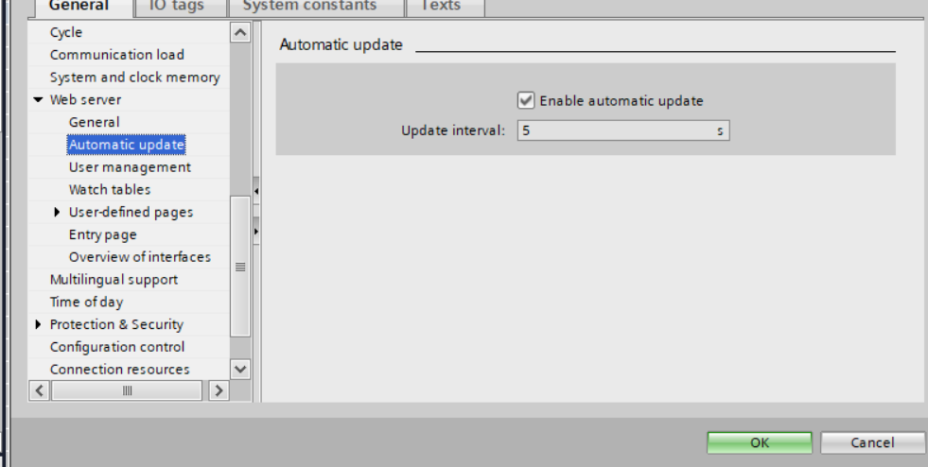Web server > Automatic update > Enable and set to 5 s (the minimum time)

Web server > User management

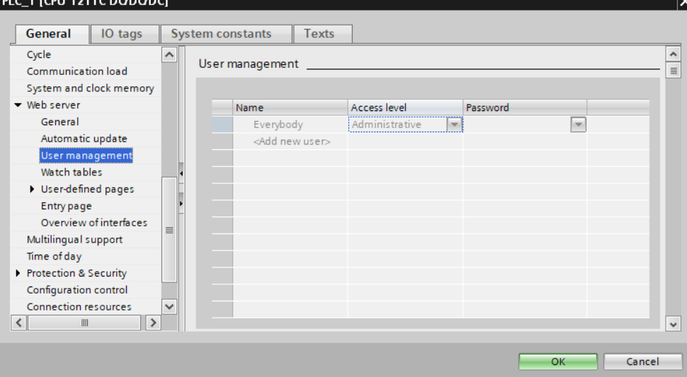Click the dropdown arrow next to Administrative and make sure all check marks are enabled

Create an HTML file with my template in MixedReality/Webpage.html

Select any folder in your local C: drive (cannot be the network X:/ drive)  
Click ‘Generate blocks’ and you’re done!

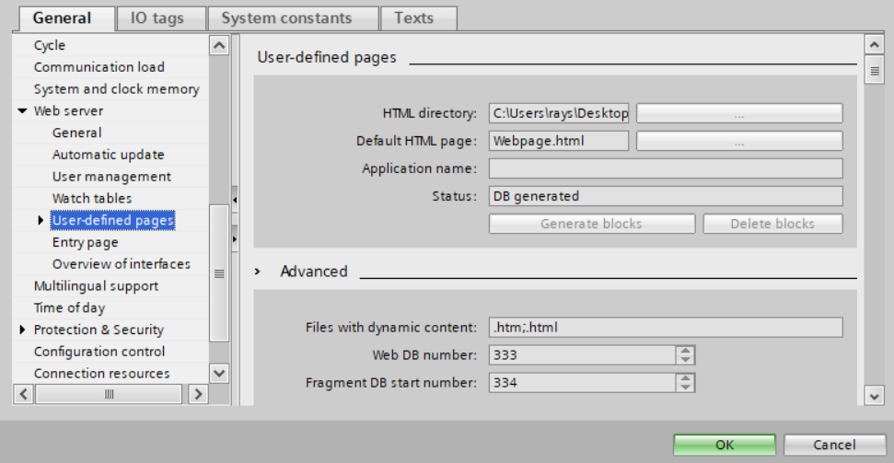

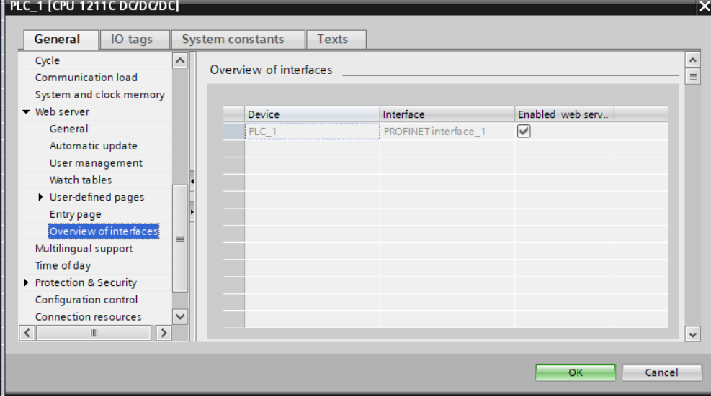

<https://www.youtube.com/watch?time_continue=267&v=DeaNgEd1wW4>